switching circuit

End to End Testing

University of Regina

ENEL 417

**Purpose:** Test the remote switching from Central Control Unit (CCU) to the Device Energy Manager (DEM)

Important Note: Please make sure the end to end Zigbee communication is tested before performing this test.

**Procedure:** In order to test this circuit, perform the following step:

1. Connect the Zigbee module to the power supply and the microcontroller board* as shown in figure 1.0 below:

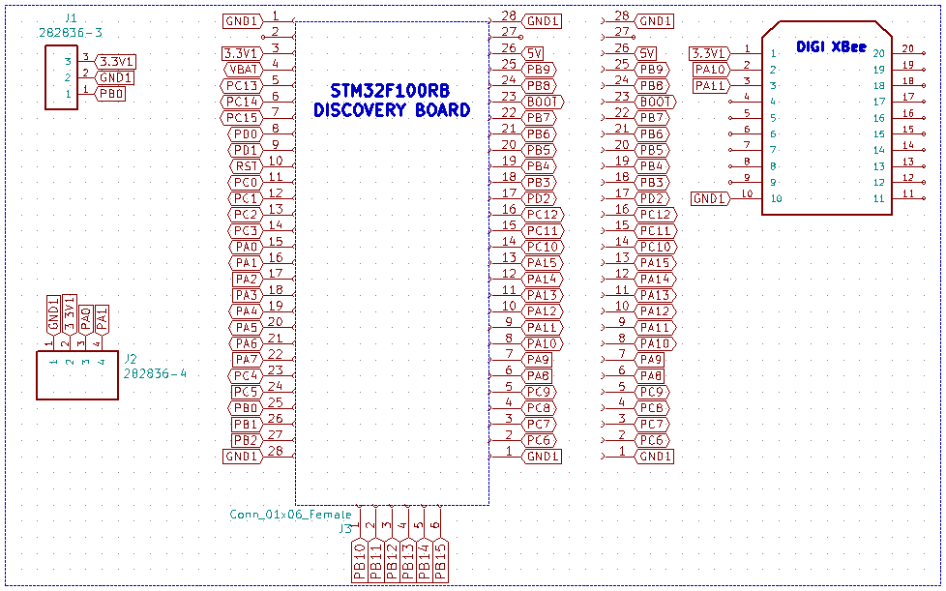

**Figure 1.0: Microcontroller and XBEE Schematic**

**\*-** For this test, please connect the Zigbee data pins (2 (Rx),3 (Tx)) to PA3 and PA2 respectively. The above schematic is for the final design and uses USART2 instead of USART1

1. Connect the switching circuit as shown in figure 1.1 below:

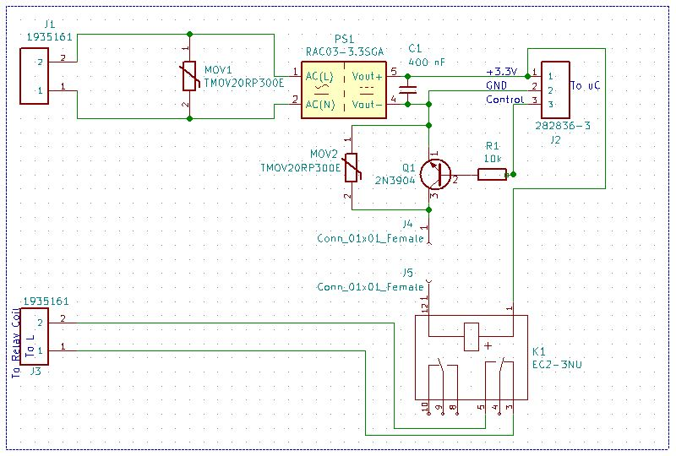

Figure 1.1: Power Supply and Switching Circuit

1. Ask the team member responsible for programming the device to load the program into the STM32 discovery board.
2. Ask the team member responsible for CCU to run the app and send the switching command via XBEE
3. The Blue LED on the STM32 board will light up indicating that the switching command has reached and the microcontroller has sent the switching signal to the switching circuit
4. Additionally, the switching circuit is connected to PB0 pin on the microcontroller. A DMM can be used to check the status of this pin in order to confirm the switching signal. The DMM will read around 3V when the pin is ‘on’.
5. In the end, the PB0 pin can be connected to the control input of the circuit in figure 1.1.
6. The DC relay can be heard energizing which will close the contacts 3 and 5. This confirms that the end to end switching is working.
7. The AC relay is not used in this test but is tested in the switching circuit test.

**Results:**

**Pass: (Y / N):**

**Date:**

Signature Signature Signature Signature

(Supervisor) Team Member1 Team Member2 Team Member3